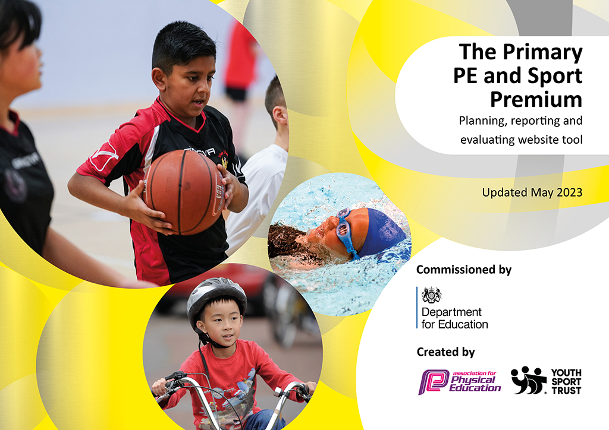
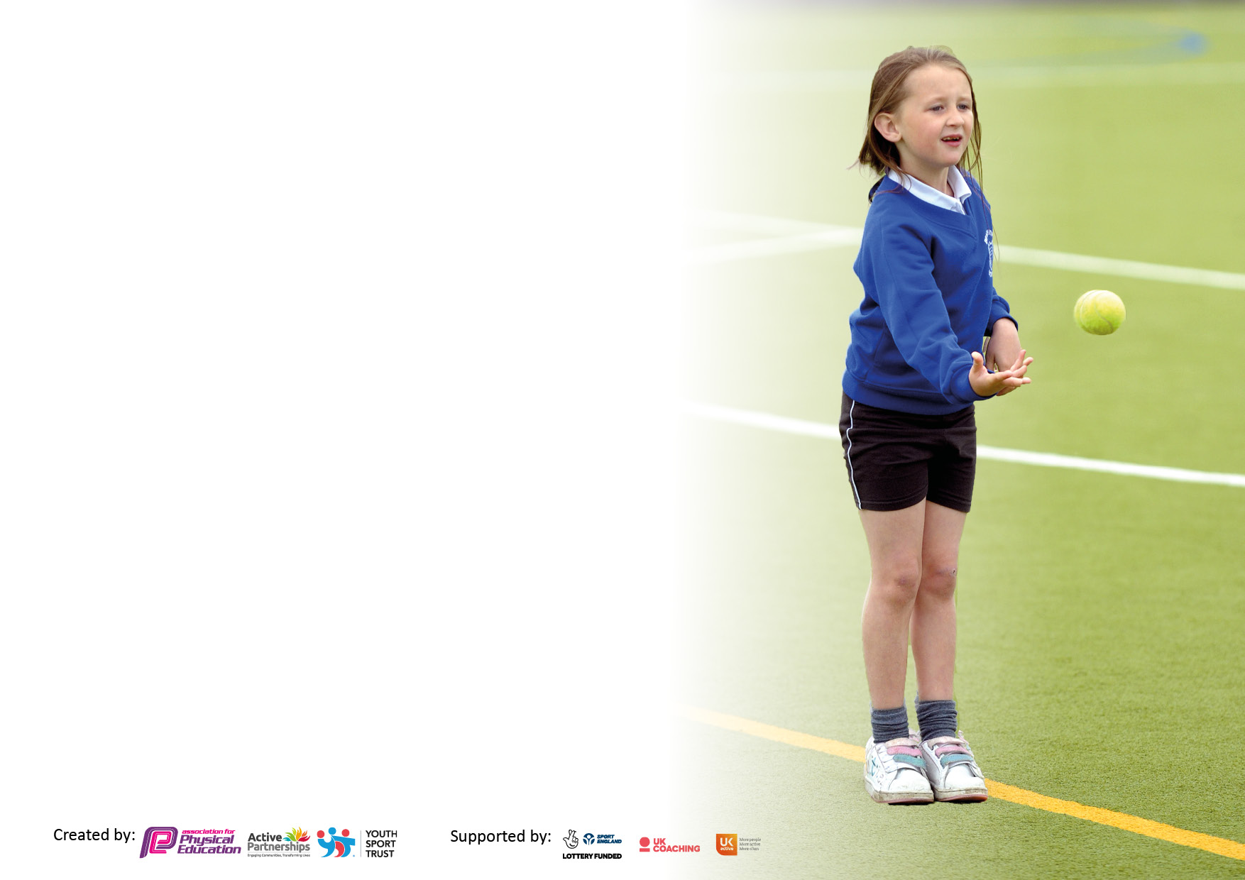

It is important that your grant is used effectively and based on school need. The Education Inspection Framework makes clear there will be a focus on ‘whether leaders and those responsible for governors all understand their respective roles and perform these in a way that enhances the effectiveness of the school’.

Under the Quality of Education judgement, Ofsted inspectors consider:
Intent - Curriculum design, coverage and appropriateness
Implementation - Curriculum delivery, teaching (pedagogy) and assessment
Impact - Attainment and progress

To assist schools with common transferable language, this template has been developed to utilise the same three headings which should make your plans easily transferable between working documents.

Schools must use the funding to make additional and sustainable improvements to the quality of Physical Education, School Sport and Physical Activity (PESSPA) they offer. This means that you should use the Primary PE and sport premium to:

- Develop or add to the PESSPA activities that your school already offers
- Build capacity and capability within the school to ensure that improvements made now will benefit pupils joining the school in future years
- The Primary PE and sport premium should not be used to fund capital spend projects; the school’s budget should fund these.

Please visit https://www.gov.uk/guidance/pe-and-sport-premium-for-primary-schools for the revised DfE guidance, including the 5 key indicators across which schools should demonstrate an improvement. This document will help you to review your provision and to report your spend. DfE encourages schools to use this template as an effective way of meeting the reporting requirements of the Primary PE and Sport Premium.

We recommend you start by reflecting on the impact of current provision and reviewing the previous spend.

Schools are required to publish details of how they spend this funding, including any underspend from 2021/2022, as well as on the impact it has on pupils’ PE and sport participation and attainment.

We recommend regularly updating the table and publishing it on your website throughout the year. This evidences your ongoing self-evaluation of how you are using the funding to secure maximum, sustainable impact. Final copy must be posted on your website by the end of the academic year and no later than the 31 July 2023.

Details with regard to funding
Please complete the table below.

Total amount carried over from 2021/22 | £0
Total amount allocated for 2022/23 | £19,569.54
How much (if any) do you intend to carry over from this total fund into 2023/24? | £0
Total amount allocated for 2022/23 | £19,569.54
Total amount of funding for 2022/23 to be reported on by 31st July 2023 | £ 19,570.00
Swimming Data
Please report on your Swimming Data below.

Meeting national curriculum requirements for swimming and water safety.

N.B. Complete this section as best you can. For example, you might have practised safe self-rescue techniques on dry land which you can then transfer to the pool when school swimming restarts.
Due to exceptional circumstances priority should be given to ensuring that pupils can perform safe self-rescue even if they do not fully meet the first two requirements of the NC programme of study
What percentage of your current Year 6 cohort swim competently, confidently and proficiently over a distance of at least 25 metres?  N.B. Even though your pupils may swim in another year, please report on their attainment on leaving primary school at the end of the summer term 2023.  Please see note above | %
What percentage of your current Year 6 cohort use a range of strokes effectively [for example, front crawl, backstroke and breaststroke]?  Please see note above | %
What percentage of your current Year 6 cohort perform safe self-rescue in different water-based situations? | %
Schools can choose to use the Primary PE and sport premium to provide additional provision for swimming, but this must be for activity over and above the national curriculum requirements. Have you used it in this way? | Yes/No

Action Plan and Budget Tracking
Capture your intended annual spend against the 5 key indicators. Clarify the success criteria and evidence of impact that you intend to measure to evaluate for pupils today and for the future.

Academic Year: 2022/23 | Total fund allocated:£19.569.00 | Date Updated: 11/7/23
Key indicator 1: Increase confidence, knowledge and skills of all staff in teaching PE and sport |  |  |  | Percentage of total allocation:
 |  |  |  | %
Intent | Implementation |  | Impact
Your school focus should be clear on what you want the pupils to know and be able to do. What do they need to learn and to consolidate through practice: | Make sure your actions to achieve are linked to your intentions: | Funding allocated: | Evidence of impact:  What do pupils now know and what can they now do? What has changed? | Sustainability and suggested next steps:
Promote high quality planning and delivery of PE lessons and opportunities for innovative ways to within PESPPA  Specialist Sports coach to teach with class teacher to delivery high quality lessons whilst up-levelling staff.  Opportunities to receive high quality CPD to enhance the teaching of PE  Use of PE scheme to support the planning and delivery of their PE lessons.  Ensure there is a broad curriculum coverage for children to progress. | Termly learning walks and conversations with staff from PE lead to monitor and record progress and improvements in PE  AfPE Safe Practice Guidance book purchased to support safety in lessons.  Suitable PE equipment and inventories completed regularly.  All KS1 and KS2 teachers to have one PE session a week team teaching with a specialist coach.  Repurchase complete PE scheme  PE lead attend conference and training to upskill and deliver to staff. – CPD opportunities provided alongside scheme.  PE specific IPAD purchased for fixtures and use during lessons.  Staff meeting/ inset day time to develop use of complete PE.  Monitor through conversations to use of and confidence of using complete PE scheme.  PE lead to rewrite long-term plan to ensure progression and variety.  PE lead out ½ day a week to organise long term plan, resources and monitor delivery of PE. | £11,153  £105  £105  £4.800 | Constructive feedback given to teachers from learning walks and drop ins which have allowed for open conversations and support.  Children have been able to experience different sports during PE lessons with the appropriate equipment eg handball/dodgeball.  Pupils have benefited from have a specialist PE teacher for 1 session a week. It provided a higher standard of subject knowledge being delivered and increased confidence among staff.  Teachers able to implement what they have seen within coach led session into their teacher led PE lesson.  Specialist coaches have provided opportunities to many children, offering them ago at new sports and having expert knowledge in that sport.  PE Lead has gained further knowledge from attending the conference, watching relevant workshops linked to increasing physical activity, how to correctly fill out relevant documents, many useful resources surrounding teaching and learning as well as what makes a high quality PE lesson.  Teachers have given feedback that they have benefited from scheme and it has helped develop confidence when teaching PE.  Missing learning (swimming) has been rectified. A variety of sports have been taught with opportunities to participate competitively inside and outside of school. | Label shed for equipment to ensure things go back where they came from.  PE teacher used in 23/24 – ensure more team teaching to develop confidence further.  Termly observations to continue – open conversation and feedback from teacher on how to develop their confidence and the support they would like.  New PE lead to attend conference and training courses – handover meetings in September before current lead leaves.  PE lead to deliver session on how to best utilize resource – ensure assessment section is set up and being used.
Key indicator 2: The engagement of all pupils in regular physical activity – Chief Medical Officers’ guidelines recommend that  primary school pupils undertake at least 30 minutes of physical activity a day in school |  |  |  | Percentage of total allocation:
 |  |  |  | %
Intent | Implementation |  | Impact
Your school focus should be clear on what you want the pupils to know and be able to do. What do they need to learn and to consolidate through practice: | Make sure your actions to achieve are linked to your intentions: | Funding allocated: | Evidence of impact:  What do pupils now know and what can they now do? What has changed? | Sustainability and suggested next steps:
To engage all pupils in regular physical activity outside of PE lessons.  To offer opportunities for all pupils to stay active within lunch times | Regular physical activities as brain breaks within the classroom.  Daily mile pushed by teachers regularly during the school day.  Play leaders to run and delivery sporting activities to children throughout lunch.  Leaflets/emails sent to children/parents to inform them of opportunities outside of school hours within the area.  Providing a range of lunch time and after school clubs for children.  Utilizing local clubs (BSFRC) |  | Participation in the daily mile has increased, with many classes completing the Daily Mile regularly. Children enjoy partaking in the daily mile and enjoy completing it as a class often asking to do it.  It has encouraged the less active children and has encouraged children to try and beat their time to increase speed and fitness.  A range of children trying new clubs and being active throughout their lunch break. | Physical tracker to be completed every term to gage physical activities levels of all children.  New playground markings across ks1 and ks2.  Ensure new children are allocated and that this is maintained throughout the year – train leaders and MSA’s training to ensure delivery of quality sessions.  Overtime for TA/MSA to oversee play leaders and lunch time games.

Key indicator 3: The profile of PE and sport is raised across the school as a tool for whole school improvement |  |  |  | Percentage of total allocation:
 |  |  |  | %
Intent | Implementation |  | Impact
Your school focus should be clear on what you want the pupils to know and be able to do. What do they need to learn and to consolidate through practice: | Make sure your actions to achieve are linked to your intentions: | Funding allocated: | Evidence of impact:  What do pupils now know and what can they now do? What has  changed? | Sustainability and suggested next steps:
Children to be able to use high quality equipment during PE lessons as a means to highlight the importance of PE  Children to attend competitions with appropriate equipment  Leadership opportunities for all children in KS1 and KS2  Communication with parents  Sports day and other interhouse competitions are key events in the school calendar. | Purchase of gymnastic leotards and netball bibs for children to wear at competitions/sporting fixtures.  Buy into the platinum offer with school partnership.  A sports council for Upper KS2 to be utilised across the year – play leaders to provide sporting opportunities during lunch.  Letters sent out to parents regarding fixtures – overview of achievements and fixtures outlines in weekly newsletter.  Sports day rewards purchased and day planned for parents to attend and support | See below  £950 +£500  £55.80 | From pupil feedback, children, liked to represent their school wearing a matching kit and felt confident when doing so.  Children are proud to see themselves at competitions representing their school and upcoming fixtures.  When possible, parents have attending competitions to support.  Children and parents enjoyed sports day and all children received reward stickers throughout the day. Moral and confidence was high throughout the day due to support given by all children and adults. | Northgate will continue to buy into sports partnership offer  Sports captains to take responsibility and support with the upkeep of the board.  New stickers to be purchased ready for next sports day -  Trophies for inter house competitions.
Key indicator 4: Broader experience of a range of sports and physical activities offered to all pupils |  |  |  | Percentage of total allocation:
Intent | Implementation |  | Impact
Your school focus should be clear on what you want the pupils to know and be able to do. What do they need to learn and to consolidate through practice: | Make sure your actions to achieve are linked to your intentions: | Funding allocated: | Evidence of impact:  What do pupils now know and what can they now do? What has  changed? | Sustainability and suggested next steps:
Increase opportunities for children to experience a new variety of different sports and activities and know how to access them outside of school. | Purchase a second shed (from PTA) for play equipment to free space for new PE equipment – ball cage to be purchased.  PE coach provide lunch time and afterschool club of a range of sports to different year groups.  Links developed with near by schools and clubs to increasing opportunities (BSRFC, Birchwood, Boys High)  Use of Grange Paddocks facilities for swimming.  New playground markings to encourage physical activity throughout break and lunch. | £149.98 | Teachers feel more confident to find equipment to use for lessons which mean higher quality of lessons.  BSRFC have come in to lead tag rugby afterschool clubs  Governor / ex netball player delivery netball club / semi pro football player delivery football coaching.  Most physically active children outside of PE lessons and clubs | Continue to move across equipment for playtime when new equipment purchased.  Continue to develop links with coaches/athletes.  Find out if any parents are able to offer coaching or support with clubs to increase participation numbers.  Summer camp running by school cool – July 23  To make wellbeing week and yearly occurrence. PE Leads to continue to build on offering the children alternative ways of exercising and have a wider variety of activities throughout the week.

Key indicator 5: Increased participation in competitive sport |  |  |  | Percentage of total allocation:
 |  |  |  | %
Intent | Implementation |  | Impact
Your school focus should be clear on what you want the pupils to know and be able to do. What do they need to learn and to consolidate through practice: | Make sure your actions to achieve are linked to your intentions: | Funding allocated: | Evidence of impact:  What do pupils now know and what can they now do? What has  changed? | Sustainability and suggested next steps:
Children have the opportunity to take park in competitions inside and outside of school to demonstrate skills and sportsmanship discussed in PE lessons. | Purchase of platinum version of the Birchwood sports partnership in order to take part in a range of competitions against other schools.  A different interhouse competitions each term.  - Tag rugby  - Football  - Netball  - Cross country | See above | From a pupil survey, children have enjoyed being able to represent the school in different competitions.  We have participated in a number of different competitions throughout the year  Events Entered:  - Football  - Cricket  - Dodgeball  - Gymnastics  - Athletics  - Netball  Children in Y5 and Y6 have taken part in netball/cricket and football club afterschool and have been a part of a league. | Purchase of the BSP platinum package to allow us to continue to take part in competitive sports.  Continue to enter events in line with the guidelines and school policy. Request with SGO for more competitive events for KS1 children to take part in.  Contact SGO about organising a friendly league for football and netball for Autumn term.

Signed off by
Head Teacher:
Date:
Subject Leader:
Date:
Governor:
Date:

